Assembling the Badge

1. Start with the black rear board.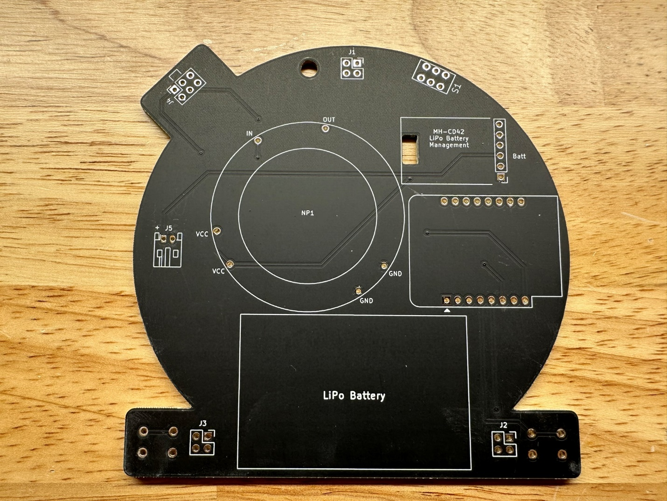
2. Solder the power switch.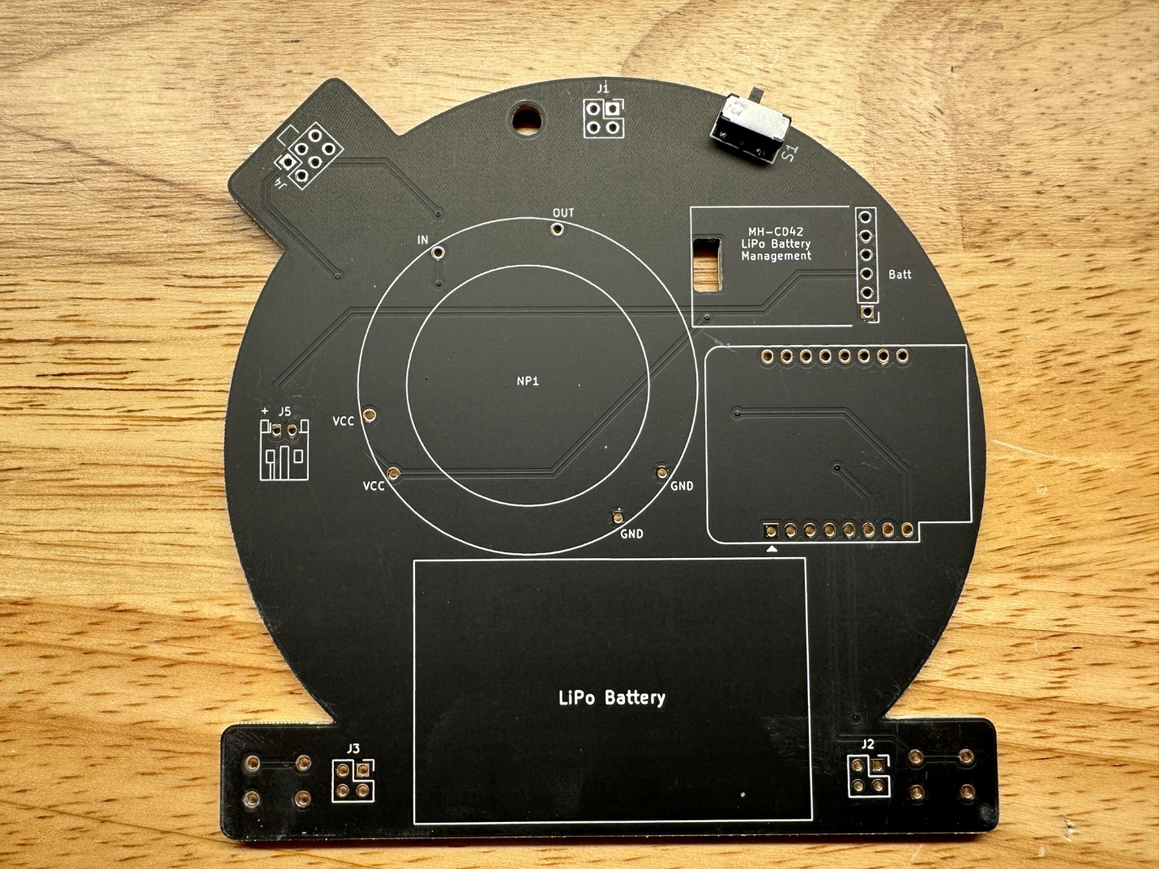
3. Solder the battery connector.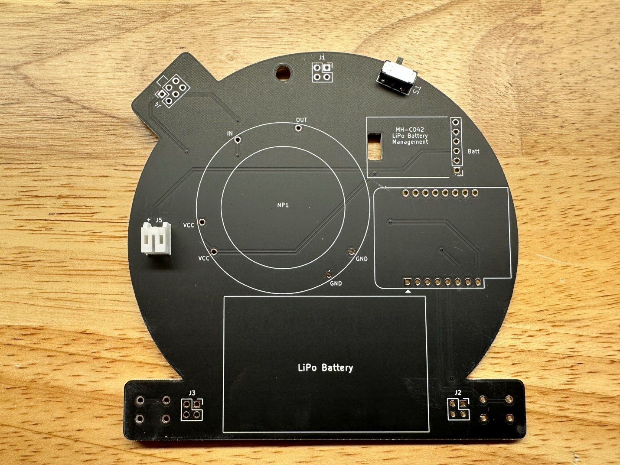
4. Solder the 3 female 2x2 headers.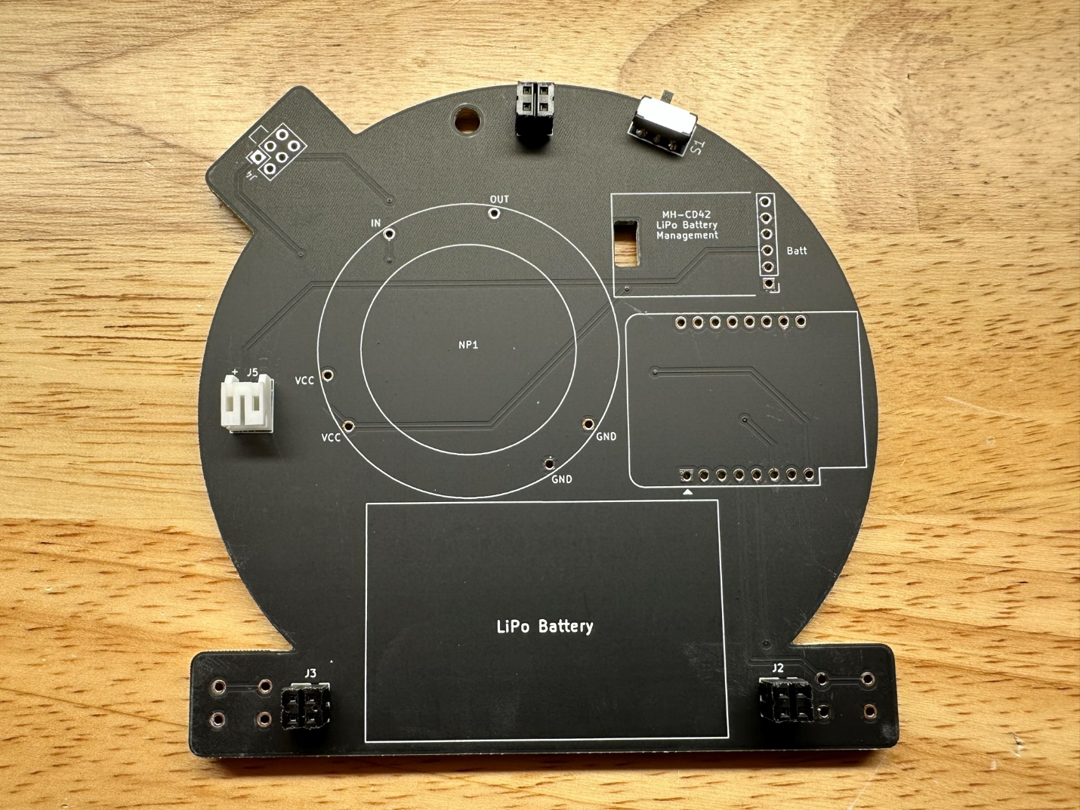
5. Solder the microcontroller as shown using 2 1x8 male header pins with the long side of the pins facing up.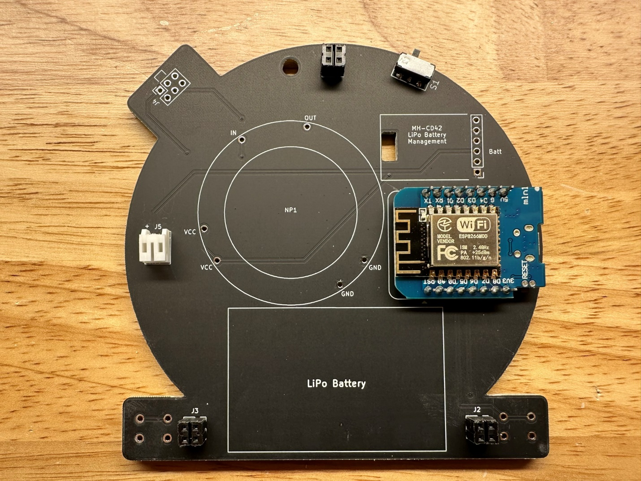
6. Find the 1x12 male header pins.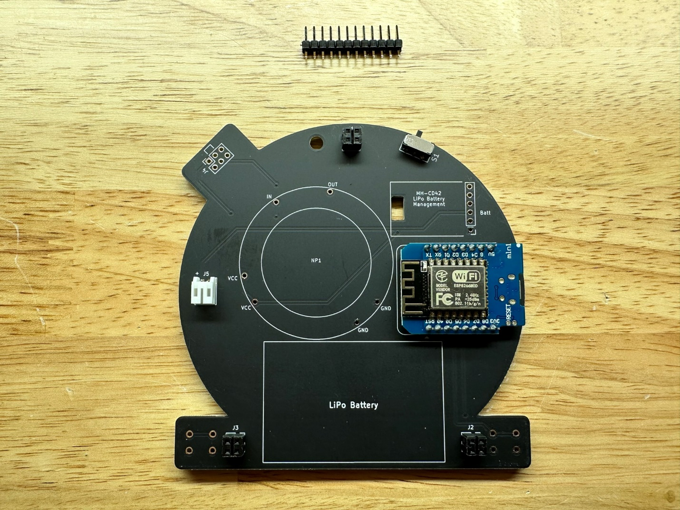
7. Cut off a 1x6 section, then cut the remainder into individual pins and set them aside for step 9. 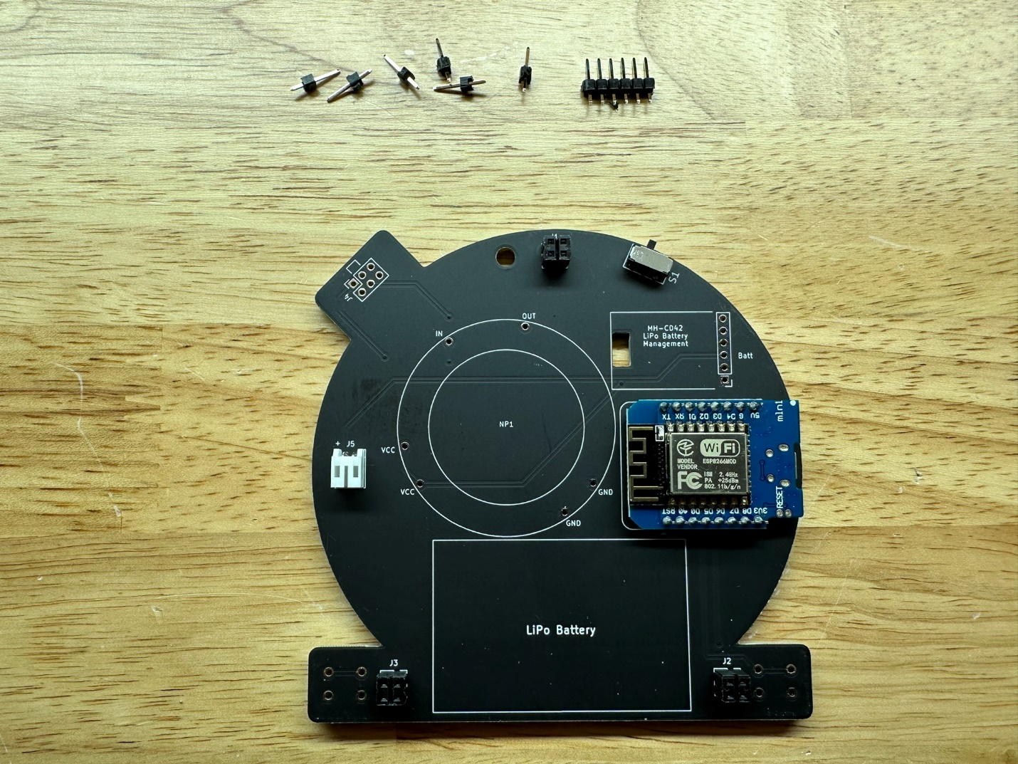
8. Using the 1x6 section from step 7 solder the battery charger module as shown with the long side of the pins facing up.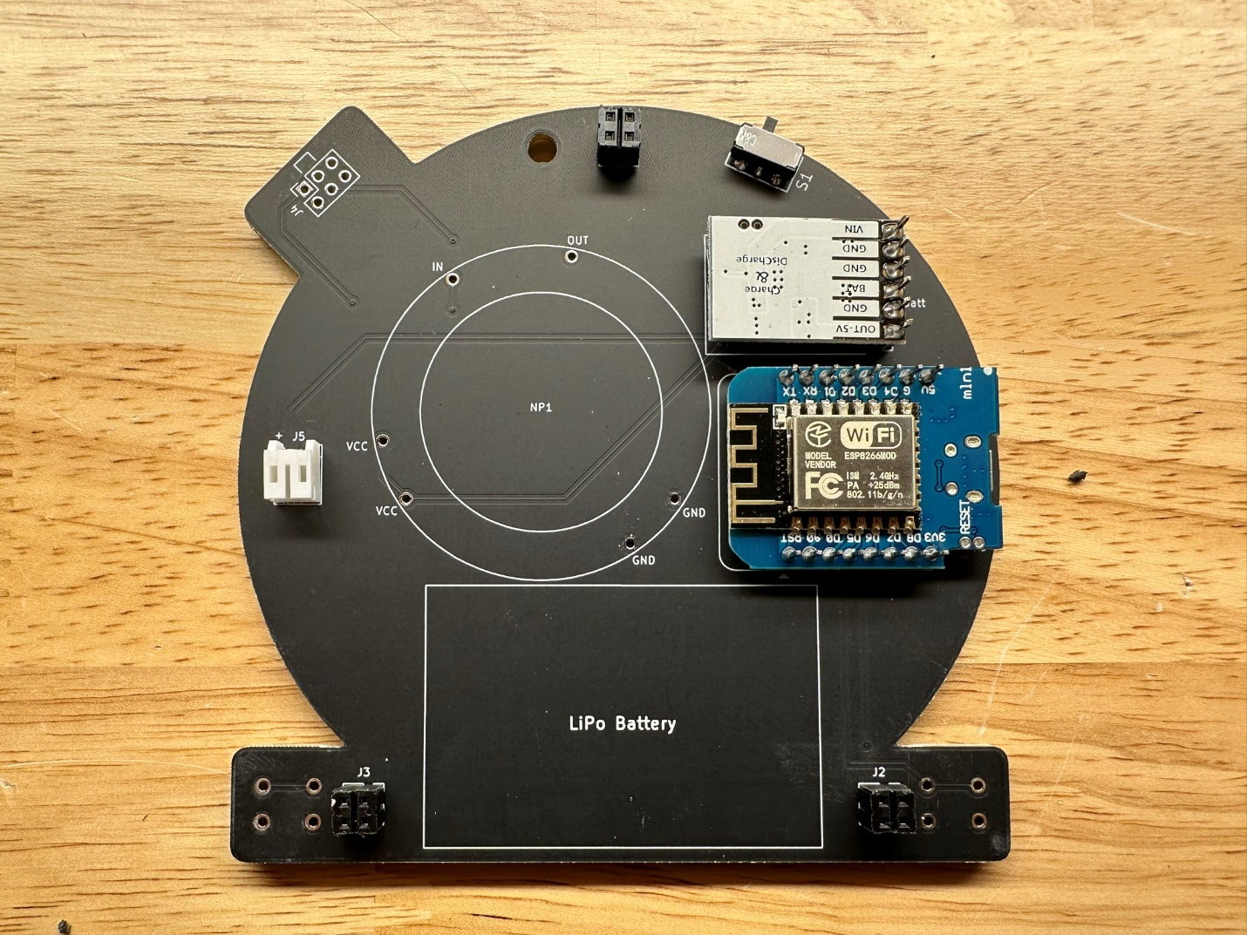
9. Using the 6 single pins from step 7 solder the NeoPixel ring.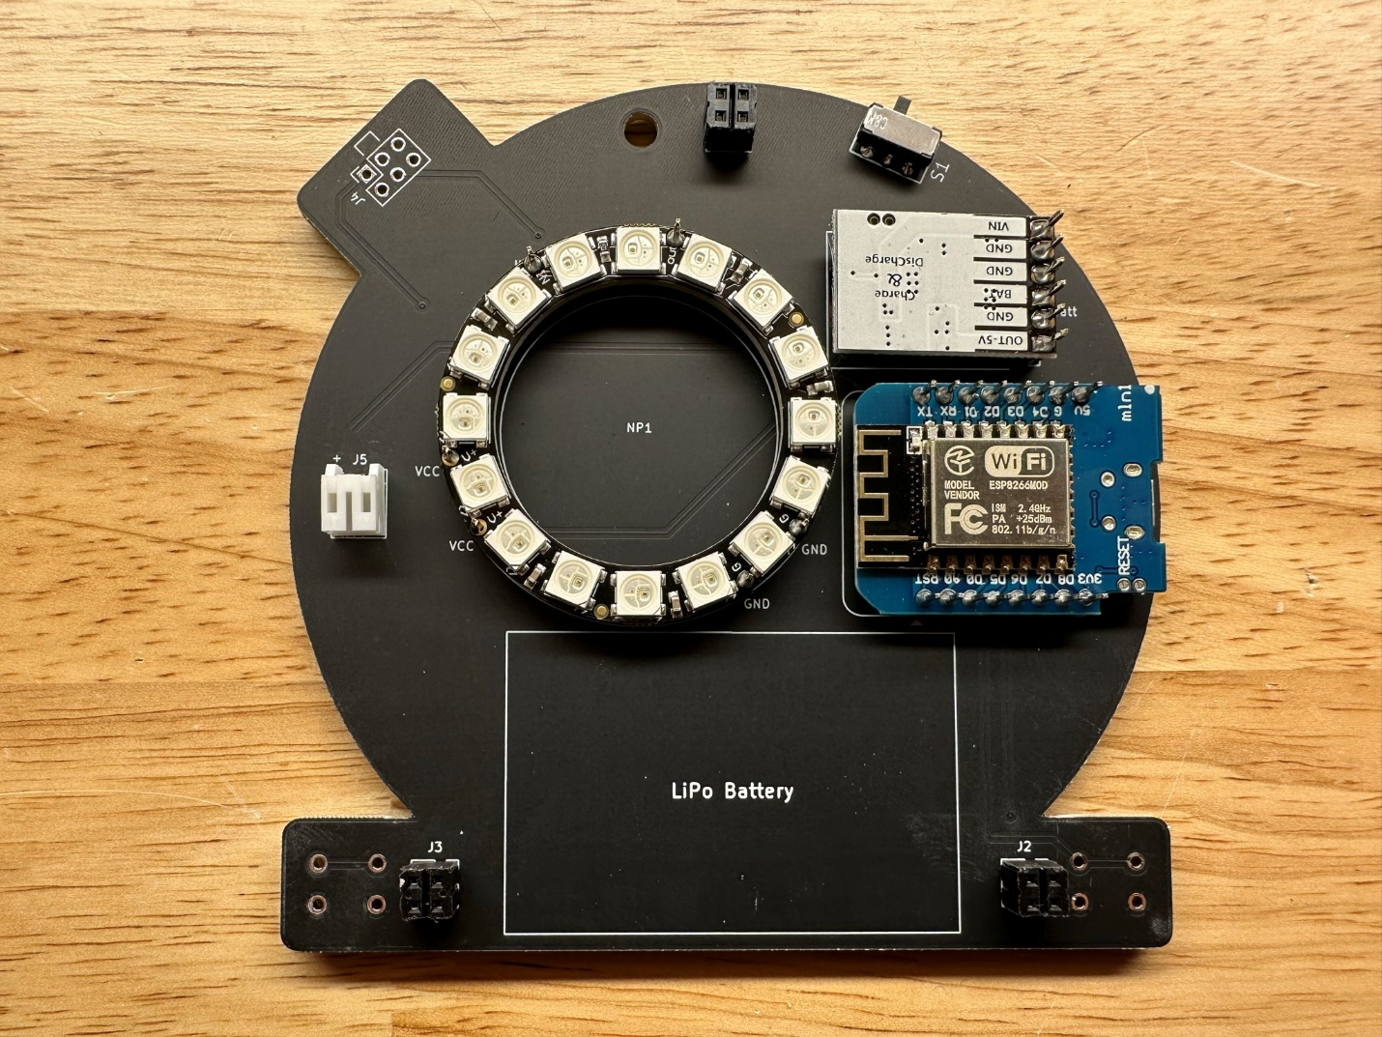
10. Solder the SAO 2x3 header, aligning the notch as shown by the silkscreen.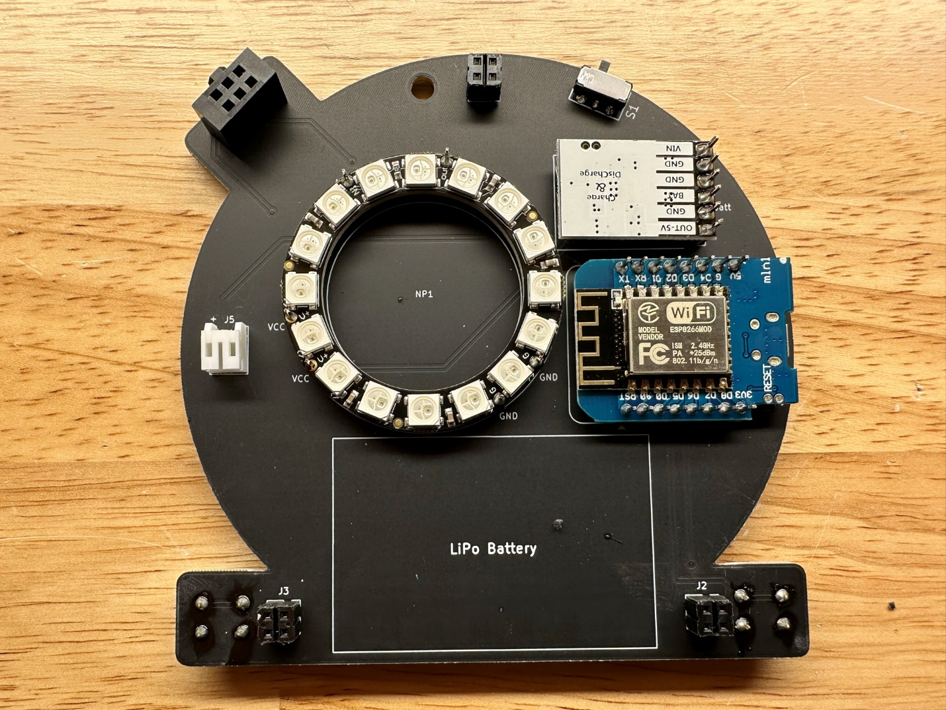
11. Solder the 2 tactile switches on the back.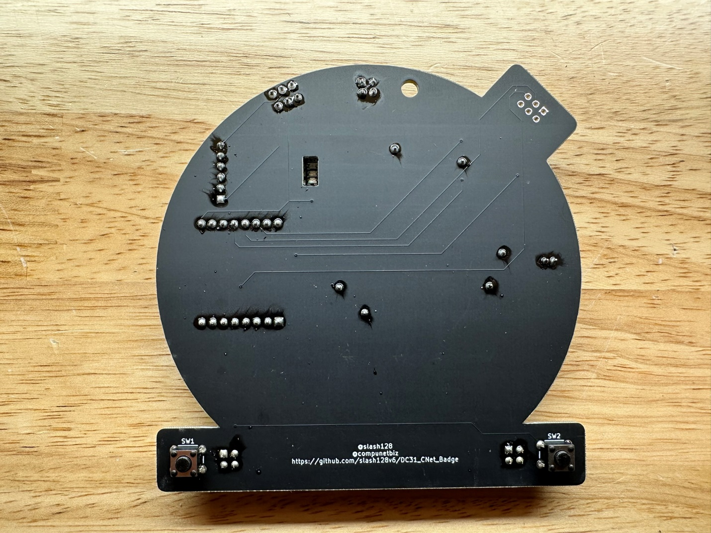
12. Use a piece of double-sided tape to mount the battery and connect as shown.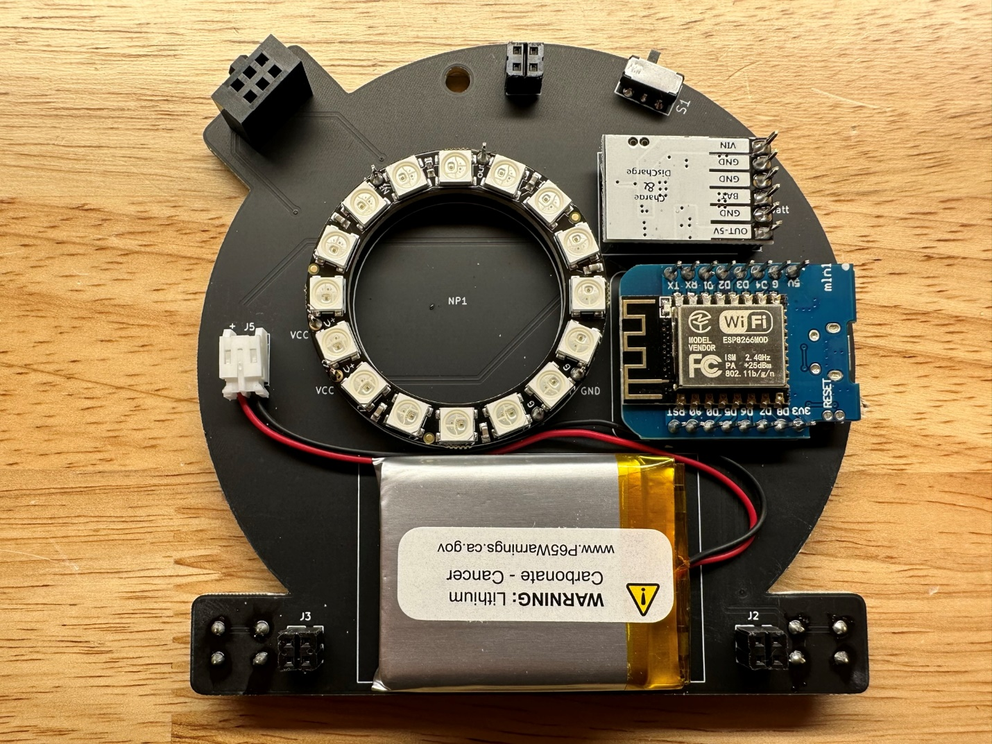
13. Solder the male 2x2 header pins to the rear of the front board. Align to the pads as best as possible so the front board will mate with the rear board. It helps to turn up the iron temp.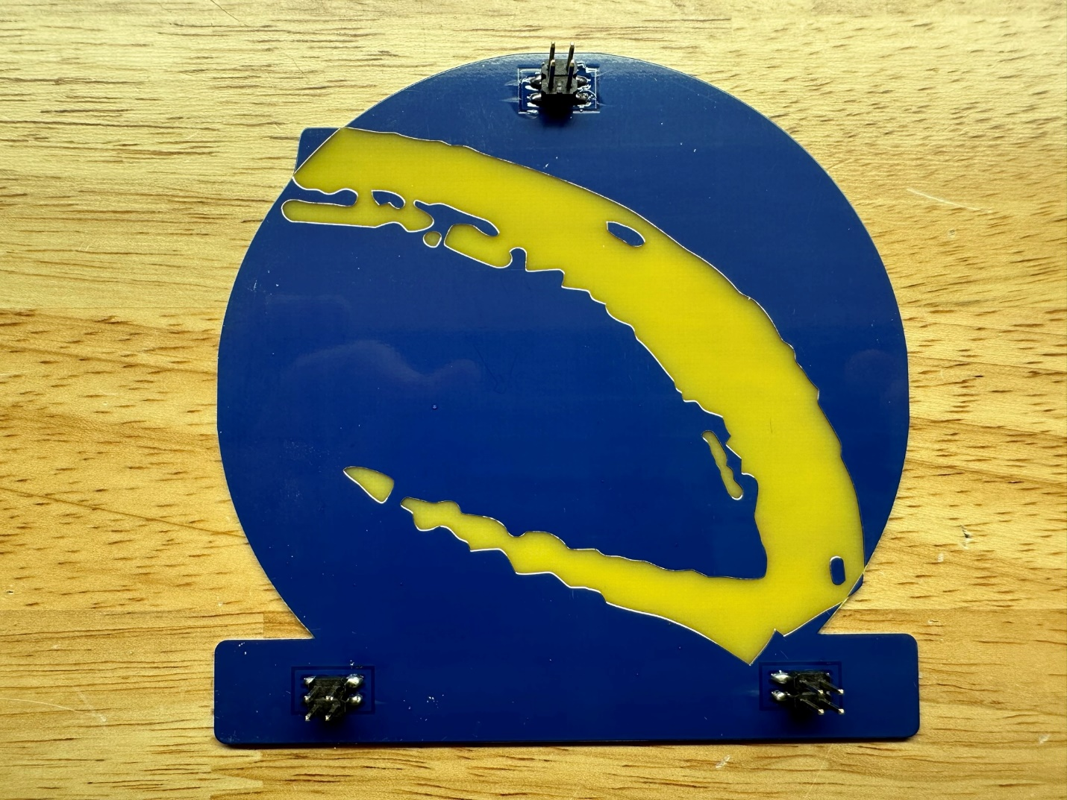
14. Align the front board male header pins with the rear board female headers and push together.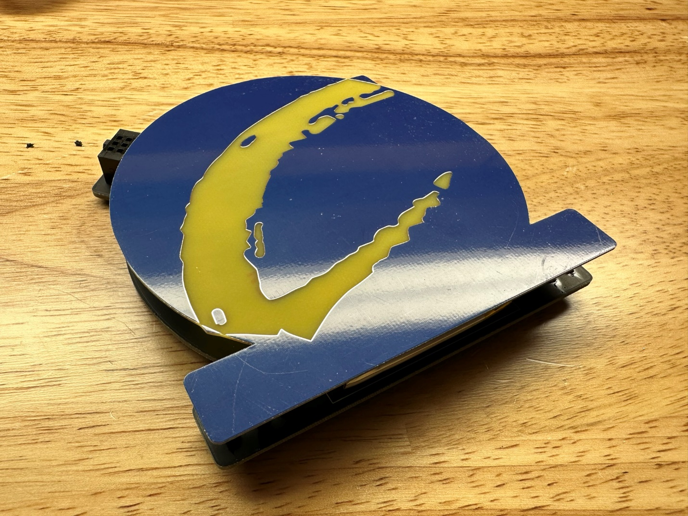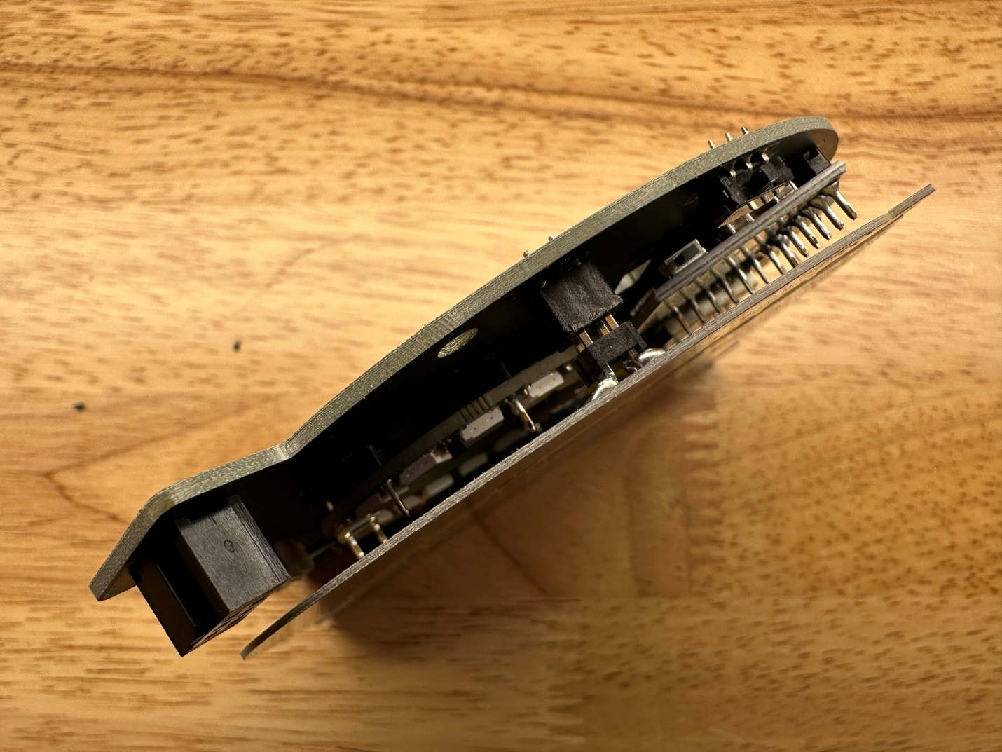
15. Slide the power switch towards the top of the board (USB power) and connect the microcontroller via USB cable.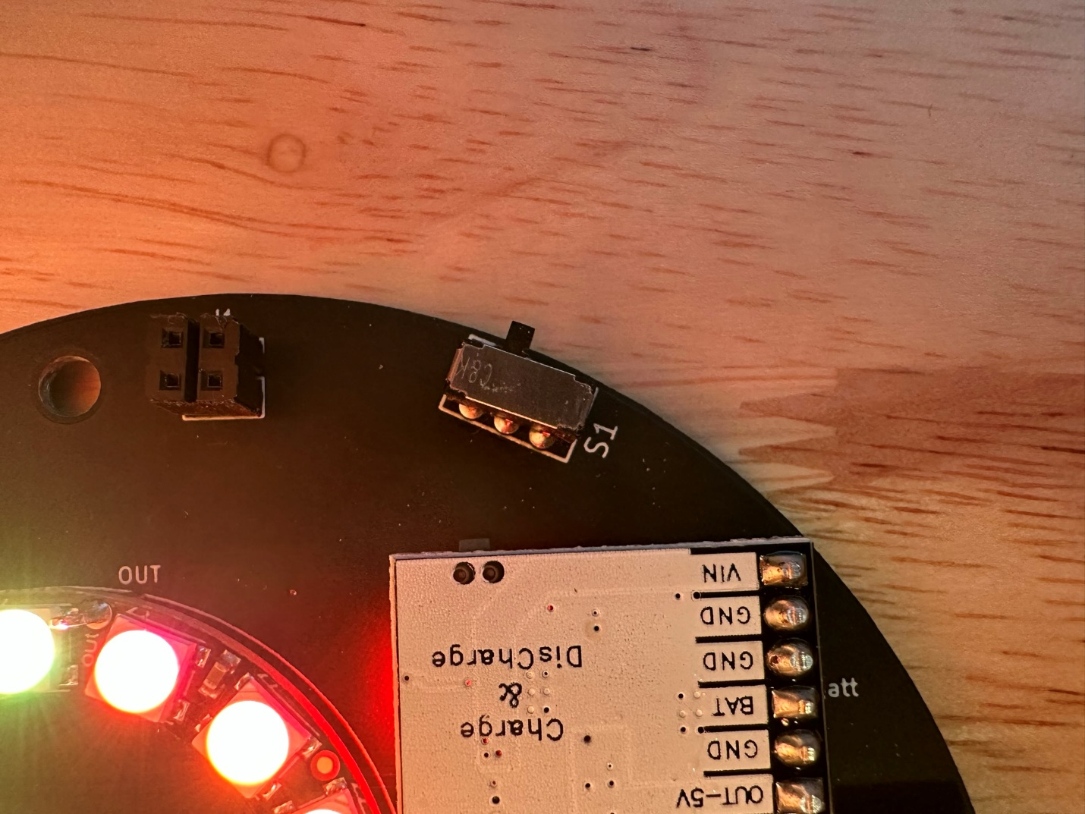
16. The charging module will light up showing battery charge level. Once at sufficient charge the power switch can be slid towards the side of the badge for battery power.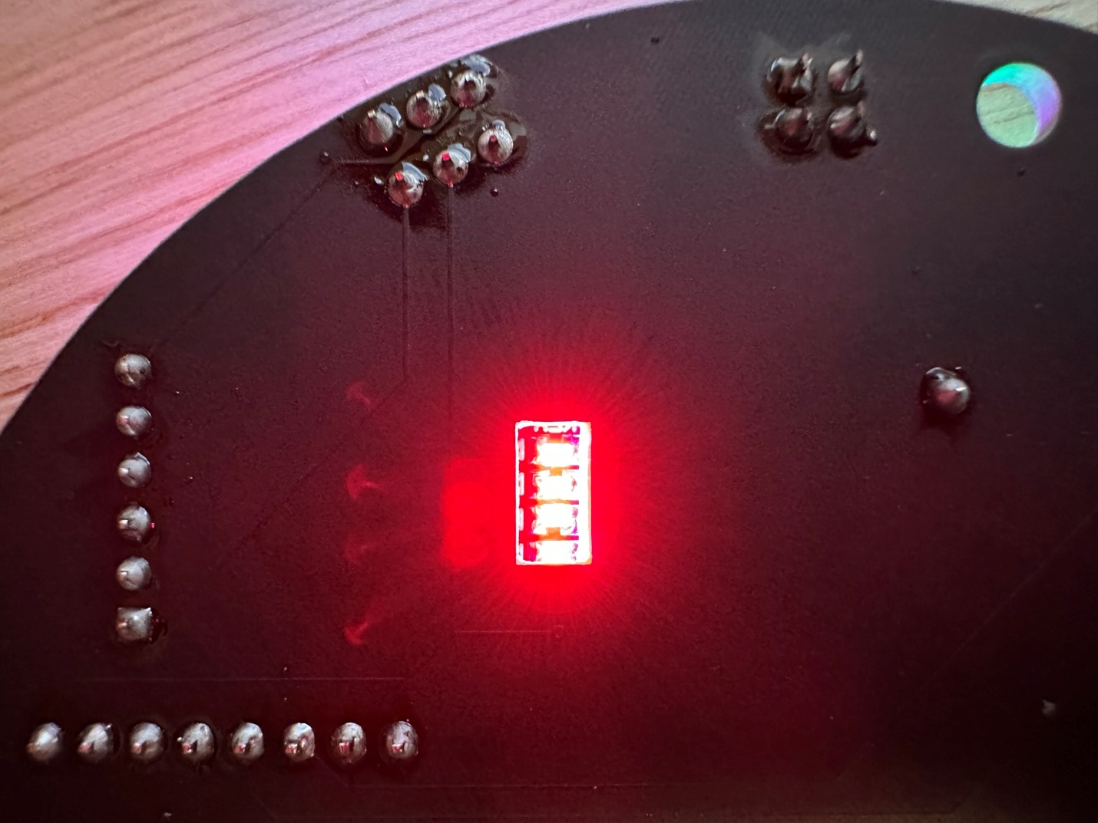

Programming the Microcontroller

// Programming the Badge from the Arduino IDE:

//

// * Download the badge repo and unzip:

// * https://github.com/slash128v6/DC31_CNet_Badge

// * Add the following to "Additional Boards Manager URLs" in preferences:

// * http://arduino.esp8266.com/stable/package_esp8266com_index.json

// * Install "esp8266 by ESP8266 Community" version 2.4.1 in Bords Manager

// * Install the FastLED library version 3.1.6 under "Sketch/Include Library/Manage Libraries" menu

// * Set the power switch to "USB" and connect to computer via USB

// * Note the COM port detected in Device Manager

Operating the Badge

// Badge Operation:

//

// The main power switch selects battery power or USB power

// USB power will charge the battery

//

// Press SW1 button to cycle through available effects

//

// Press and hold SW1 button for one second to switch between auto and manual mode

//

// * Auto Mode (two green blinks): Effects automatically cycle over time per cycleTime

// * Manual Mode (two red blinks): Effects must be selected manually with left button

//

// Press SW2 button to cycle through available brightness levels

//

// Press and hold SW2 button for one second to reset brightness to default value

//

// For WiFi control connect the SSID using the key, both defined in "secrets.h"

// (recommended to change to something unique)

// Using a web browser connect to http://192.168.4.1

// The same functions available using buttons are available on the web page

//

// Brightness, selected effect, and auto-cycle are saved in EEPROM after a delay

// The badge will automatically start up with the last-selected settings

//

// * Under the "Tools/Board" menu select the “Wemos D1 R2 & mini” option under "ESP8266 Modules"

// * Under the "Tools/Port" menu select the COM port detected when plugging in the board to USB

// * Upload the sketch

// * Once upload is complete the NeoPixels will start to cycle through the patterns